Term 1
Friday 7th February 2020
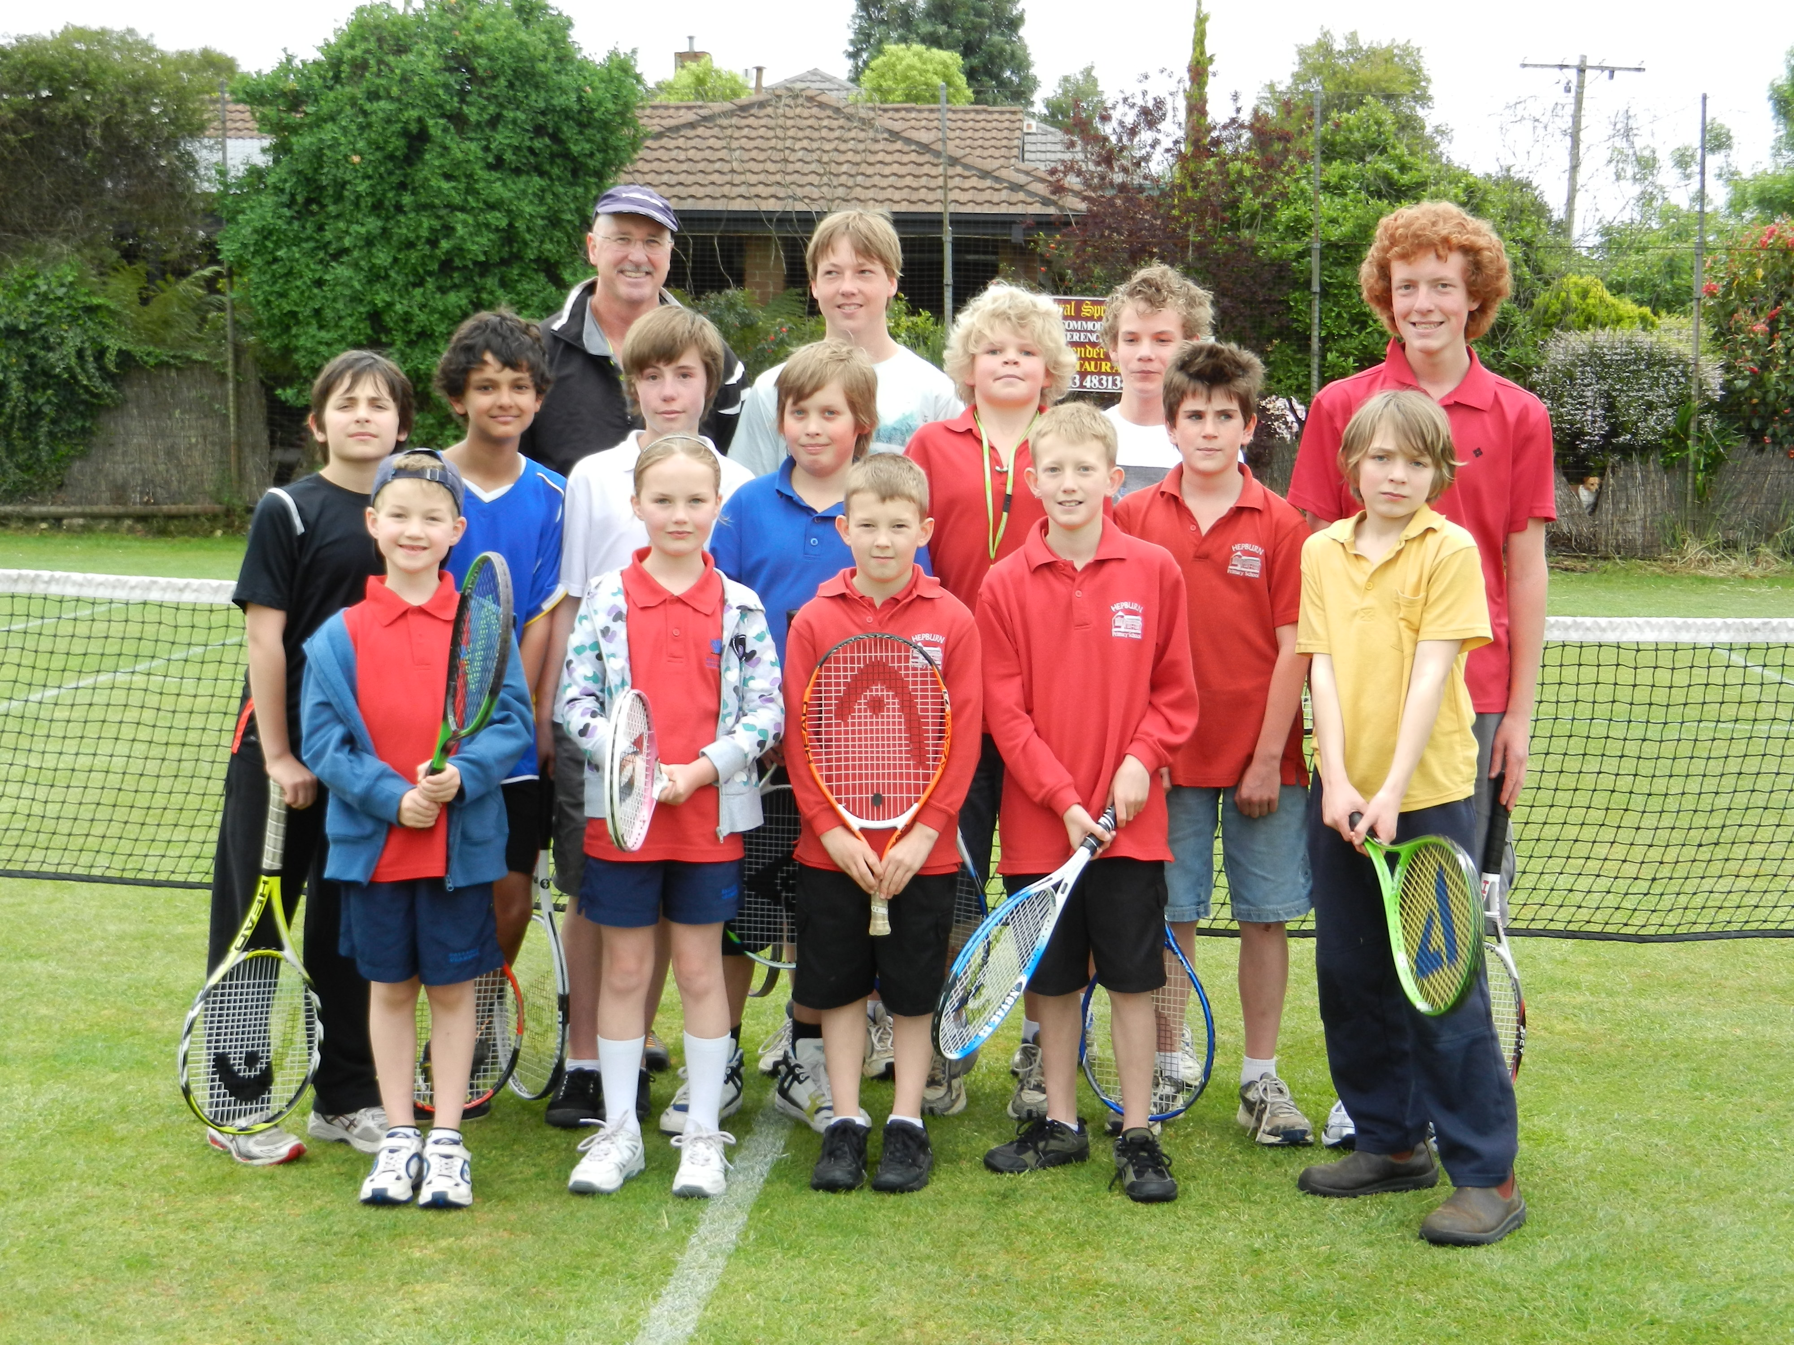
Term: 6 sessions
Format: 45 -minute sessions
Cost: $85 (GST inclusive)
Times: Friday from 3.30pm.

Book early!

Contact Brian on 54632378 or 0409189736
Location: Daylesford Lawn Tennis Club
Tennis racquets available personally fitted to suit your game and size, so don’t buy before you try.

Come 6.15pm any Friday during term to buy a racquet
Grips and restrings available talk to Brian.
MUM's and DADs
Tennis Program commence Friday 7 February 2020 5.30 to 6.15 pm

Coaching starts at Daylesford Term 4 Friday 9Th Oct 2020

YOUR Lesson time is on Friday 9th Oct 2020

If you wish to CANCEL your booking please contact Brian on 0409189736 at least 7 DAYS before coaching commences.
Terms & Conditions: Once you are enrolled in Brian Carr Tennis Coaching it is expected that you will attend the following terms lessons. If you wish to cease lessons, it is expected that you will notify Brian Carr, prior to the commencement of the following term, otherwise the following term’s fees will be charged.
Fees to be paid no later than the first lesson of term.

Please return this section to Brian before the end of term
Name:
Phone:
Preferred lesson time: ................... Medical conditions.................

